11.23: 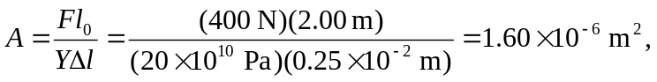
and so 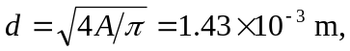or 1.4 mm to two figures.

